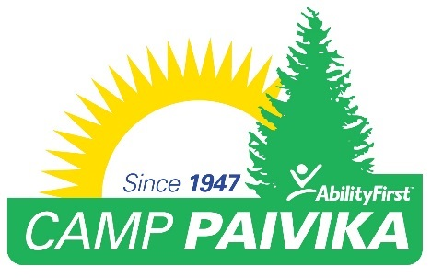
FOR IMMEDIATE RELEASE:
Media Contact:
Rebecca Haussling
Tel: 626-639-1745
Email: rhaussling@abilityfirst.org

AbilityFirst Camp Paivika Celebrates 70 Years of Summer Camp and Service to People with Disabilities
Organization will hold event on Saturday, July 29th with traditional camp activities and a program

(Crestline, CA) June 13, 2017 – Located in the beautiful San Bernardino National Forest, Camp Paivika offers overnight summer programs for children and adults with disabilities such as autism, ADHD, cerebral palsy, epilepsy and Down Syndrome. Camp Paivika will hold an event on Saturday, July 29th with campers, alumni, donors and friends that will include traditional camp activities, a picnic on the green and a short presentation in the outdoor amphitheater. The presentation will be led by Camp Director Kelly Kunsek and will recognize the 70 years of camp programs and services provided to tens of thousands of campers over the years.

“We are delighted to celebrate another incredible milestone for Camp Paivika – 70 years of service for people with disabilities, to have a traditional camp experience,” said AbilityFirst CEO Lori Gangemi. “We look forward to continuing to provide memories for a lifetime for each camper who attends Camp Paivika. Thank you to the ongoing support of our donors who help us make camp happen every year.”
The camp opened its doors in 1947 as one of the first and only fully accessible camps in the United States. Paivika (pronounced pi-vee-ka) means, “dawn” in the language of the Cahuilla Native Americans.

Camp Paivika offers children and adults the opportunity to have a traditional camp experience, provided with nurturing support and with an emphasis on safety and FUN! Days are filled with highly regulated morning to night activities, created and adapted to enable people with disabilities to have fun and encourage participation for all campers. All staff is trained and prepared to provide personal care as needed including caring for campers who are incontinent and who require assistance with feeding, bathing and other personal care.

Camp Paivika offers not just a traditional camp experience but the families of campers, who provide care for their family members with disabilities 24/7 appreciate the respite they get from the rigors and challenges of providing around the clock care.

WHAT: Camp Paivika 70th Anniversary Celebration
WHEN: Saturday, July 29, 2017 10a.m. – 4 p.m.
WHERE: Camp Paivika 600 Playground Drive, Crestline, CA 92325
RSVP: Press are invited to spend the afternoon at Camp Paivika and cover this unique celebration RSVP to camppaivika@abilityfirst.org

For press inquiries please contact Rebecca Haussling rhaussling@abilityfirst.org or 626-639-1745.

###

About AbilityFirst
For more than 91 years AbilityFirst has been providing programs and services throughout Greater Los Angeles for children and adults with disabilities. AbilityFirst provides a variety of programs designed to help people with disabilities achieve their personal best through their lives. This is accomplished through targeted programming to help an individual successfully transition from childhood to adult life, providing employment preparation and training, building social connections and fostering independence while offering both our participants and their caregivers an opportunity to recharge through our recreational activities, including Camp Paivika. More at www.abilityfirst.org and www.camppaivika.org.

