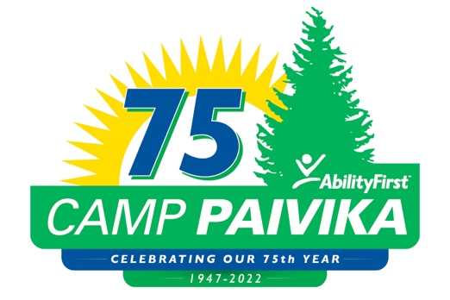

FOR IMMEDIATE RELEASE:

CAMP PAIVIKA CELEBRATES 75 YEARS OF SHARING A TRADITIONAL CAMP EXPERIENCE WITH CAMPERS, AND THEIR FAMILIES

July 26, 2023 (Crestline, Ca) - For 75 years thousands of campers and their families have enjoyed Camp Paivika, a fully accessible camp in the San Bernardino Forest offering a traditional camp experience, and a place to create cherished memories for children and adults with disabilities.

Camp Paivika recognized the milestone with an event on Sunday July 16th. More than 250 guests enjoyed the festivities including arts and crafts, tie-dye, swimming, and lunch. The occasion also paid tribute by dedicating the amphitheater to longtime supporter, Lena Longo.

Lena’s daughter Nancy and her adult sister Patty were on hand for the unveiling of the Lena Longo Amphitheater plaque. The Longo family was introduced to Camp Paivika when Patty was just seven years old, and it became like a second home for her as she spent countless fun-filled summers at camp, over the years.

The event program continued with a sing-along, a skit featuring Camp Paivika staff and members of the “Paivika Champions” a fundraising group comprised of camp alumni, and current president of the Los Angeles Rotary (LA5) Gary Jimenez presented AbilityFirst CEO Lori Gangemi and Camp Director Kelly Kunsek, with a check in the amount of $10,000 to support camp programming.

###

Camp Paivika was established in 1947 as one of the first fully accessible camps in the nation. It has helped tens of thousands of children and adults with disabilities enjoy traditional camp activities that are creatively adapted to enable fun and encourage participation from all the campers. For 75 years, Camp Paivika has been guided by the principle, “can” and not, “can’t” and the staff makes sure that no one is ever left out. Families and caregivers of campers also enjoy the opportunity to have respite from providing around the clock care for their loved ones. To learn more visit camppaivika.org.

MEDIA CONTACT:
Rebecca Haussling
Tel: 626-639-1745
Email: RHaussling@abilityfirst.org

