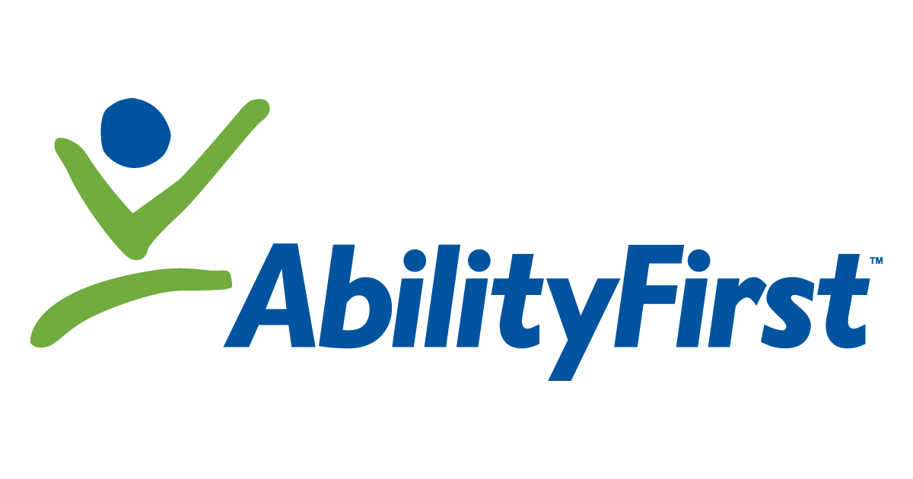 NEWS RELEASE

AbilityFirst and FVO Solutions Celebrate Historic Merger
at Ribbon-Cutting Event in Pasadena, Calif.

(PASADENA, Calif.) August 24, 2021 – With 95 years of experience and more than 50 years in Pasadena, AbilityFirst (formerly known as the Crippled Children’s Society) celebrated its merger with FVO Solutions, Inc. (formerly known as Foothill Vocational Opportunities) at a ceremonious ribbon-cutting event on Friday, Aug. 20 at AbilityFirst’s Fair Oaks location, in Pasadena.

By joining forces, AbilityFirst and FVO Solutions are uniquely positioned to deliver critical and transformational support services to an expanded population of more than 2,000 people with developmental disabilities, and their families throughout Los Angeles County.

“This merger has allowed us to expand each of our unique services while ensuring that people with disabilities and their families have a wider access to a variety of programs that can help to transform their lives. It has been a truly remarkable experience so far and we look forward to what the future holds for our united organizations,” said AbilityFirst CEO Lori Gangemi.

The ribbon-cutting celebration took place at AbilityFirst’s Fair Oaks building in Pasadena, which is also the location of the AbilityFirst Manufacturing, Supported Employment and PossAbility programs. This program was made possible by the merger because it combined FVO Solutions’ enterprising manufacturing services with AbilityFirst’s innovative, person-centered employment and community-based programs.

Prior to the ribbon cutting, Lori Gangemi welcomed guests and proclamations were presented by US Rep. Judy Chu, who addressed guests as well as, Pasadena District 3 Councilmember John J. Kennedy. Certificates of recognition were presented by field representatives from the offices of Senator Anthony Portantino, Assemblymember Chris Holden, and Pasadena Mayor Victor Gordo. AbilityFirst’s leadership, board of directors, the Pasadena Chamber of Commerce, and donors were in attendance. After the ribbon cutting, guests were given private tours of the manufacturing floor.

The combined organization is led by AbilityFirst CEO Lori Gangemi and remains headquartered on Green Street in Pasadena. AbilityFirst looks beyond disabilities, focuses on capabilities and expands possibilities. To learn more about AbilityFirst, visit abilityfirst.org.

# # #

About AbilityFirst’s Three Expanded Programs

ExploreAbility is a licensed adult day and community integration program. The goals of the ExploreAbility program are to help adults explore and identify what is important to them, to develop the skills necessary to achieve their goals and to be involved in their communities through volunteering and community activities. Individual support and small-group activities promote interaction and learning. The program is designed to help individuals access their communities in their daily lives, work, recreational and leisure activities. It incorporates volunteering, community activities, independent living and skill-building, using a small group model. ExploreAbility is currently offered at the AbilityFirst Joan and Harry A. Mier Center in Inglewood and the AbilityFirst Lawrence L. Frank Center in Pasadena.

PossAbility is intended for adults who want to enhance their skills and independence, and to participate in their communities. Individuals in the program are empowered to set and pursue personal goals with an emphasis on employment readiness and increased community connections, including volunteering. The program is offered in Pasadena and Los Angeles. The PossAbility program is designed to help adults with developmental disabilities to:
- Discover what is important to them; their interests, abilities and goals
- Learn about what is important to them to achieve their goals
- Become involved in their communities in their daily lives, work, volunteering and leisure activities
- Make friends, increase skills and participate with others who share the same interests and goals
- Enhance their skills in the areas of job readiness and employment, communication, socialization, independent living and healthy living skills

DiscoverAbility is a program that allows participants to complete in-depth assessments and career exploration by trying out new work experiences and volunteer opportunities on their journey to becoming employed.

About AbilityFirst

AbilityFirst provides a variety of programs that have a common mission: to help people with disabilities realize their full potential throughout their lives. As we celebrate more than 95 years of service, we are focusing our efforts on programs that are proven to have the greatest impact on a person’s success: basic life skills enhancement through our children’s and adult programs; higher education and employment readiness; and independent living and social and recreational programming.

AbilityFirst looks beyond disabilities, focuses on the capabilities of each individual and breaks through any preconceived limitations, opening up a world of possibilities. Preparation, socialization, communication, education – all leading to helping people achieve their personal best. To learn more visit abilityfirst.org

Media Contacts:
Rebecca Haussling, AbilityFirst
RHaussling@abilityfirst.org. / 310-922-7384

Marisol Barrios Perez, Mission Driven PR
Marisol@missiondrivenpr.com / 310-713-8567

