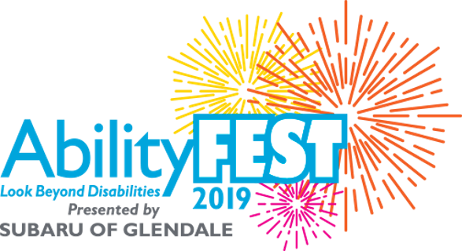

FOR IMMEDIATE RELEASE:
Contact: Rebecca Haussling
Email: RHaussling@abilityfirst.org
Tel: 626-639-1745

AbilityFEST Presented by Subaru of Glendale Gathered More Than 2,400 Attendees
The event held at the LA State Historic Park to celebrate inclusion and
to look beyond disabilities

July 24, 2019 (Pasadena, CA) – More than 2,400 attendees came together for the 2019 AbilityFEST at the Los Angeles State Historic Park. There were nearly 40 exhibitors in the inter-active expo area showcasing their latest products and services from innovative solutions for the disability community and sensory experiences like virtual reality and an adaptive rock-climbing wall, to a dunk tank and hydro-blast water activity to keep attendees cool. Plus, arts and crafts, health and wellness, food trucks, savory treats and a beer garden hosted by Golden Road Brewing.
AbilityFEST was produced by AbilityFirst, a 93-year old not-for-profit supporting children and adults with disabilities with programs to help achieve their personal best. The event offered a unique platform for the organization, along with its program participants, their families, donors and corporate partners and volunteers to enjoy the day, alongside the general public. Throughout the day, AbilityFirst shared the mission of looking beyond disabilities, focusing on capabilities and expanding possibilities for the 2,000 participants the organization serves annually.
“It was exciting to see so many new faces and watch many of the AbilityFirst participants get up onto stage and dance or perform in front of thousands of people, “said AbilityFirst CEO Lori Gangemi, “it was rewarding to see all the various attendees; both new and long-standing supporters enjoying all the activities geared towards celebrating inclusion.”
The event kicked off with a complimentary breakfast sponsored by Bank of America and a stroll/roll/walk along the grounds of the Los Angeles State Historic Park. The day continued with several live performances from participants at the Lawrence L. Frank Center in Pasadena, Long Beach Center and College to Career students, plus a heart-warming poem presented by a young man from the AbilityFirst Glendale Center. Attendees
AbilityFEST was a free community event graciously sponsored by Subaru of Glendale, Bank of America and Comerica Bank.
About AbilityFirst
AbilityFirst offers a variety of programs geared to strengthen and cultivate skills that give individuals the necessary tools to successfully navigate each transition in life, including building social connections and independence; employment preparation, training and experience; and, fun and engaging activities that offer an opportunity to refresh and recharge.
For Press inquiries contact Rebecca Haussling for more information rhaussling@abilityfirst.org / or call 626.639.1745

